**MOA Store**

**ANDROID Application**

**~Final Documentation~**

**Subject:**  Mobile Devices

**Students:** Munteanu Andreea Valentina

Obreja Ramona Oana

Group: 1232E

***MOA APPlication***

The idea of our application consists in developing an online jewelry store.

On the first page, the initial one, we have a log in form, which enables the user to access his/ her own account (1), in case it exists. In case it does not, he/ she can create a new one, by submitting his/her personal data into the SignUpActivity form (inserting the username, the password two times, the email and the favorite site that will personalize later his/ her personal page) and after that, use that account newly created to enter the shop (2).

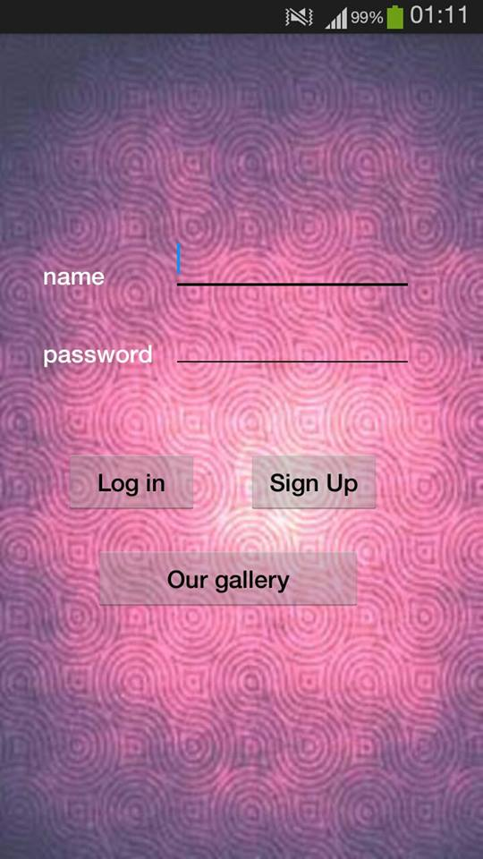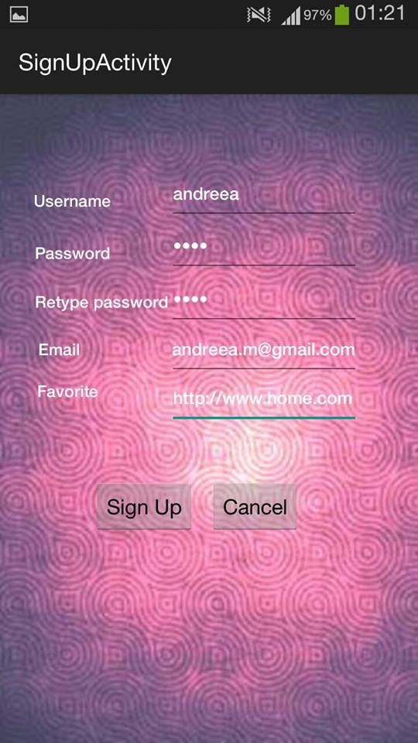

There is also a solution for a user that is not decided to buy something yet; he/ she can see pictures of our best-selling products, by clicking the “Our gallery” button. The top 10 photos are attentively selected, in order to define the public`s options of the month. (3) & (4)



Therefore, “Our gallery” is a new activity containing our virtual catalogue, with the newest products from the online shop, a very useful information source for the loyal customers, as well as for the people who want to get familiar with our brand.

In order to test the application`s functionalities, we made initially a database, having a default account as well (with username:dev and password:pass), where the information identifying the new user is stored.

In case the user writes his/ her name incorrectly (5), the following toast is displayed: “Wrong username or password!”. This means that the data introduced is not valid, so the log in process failed. (6)

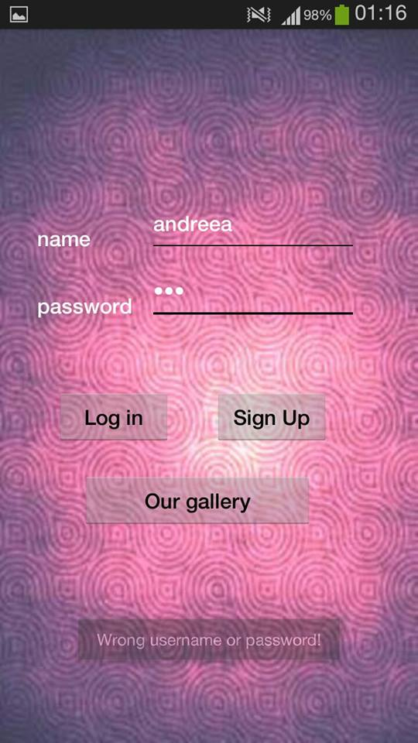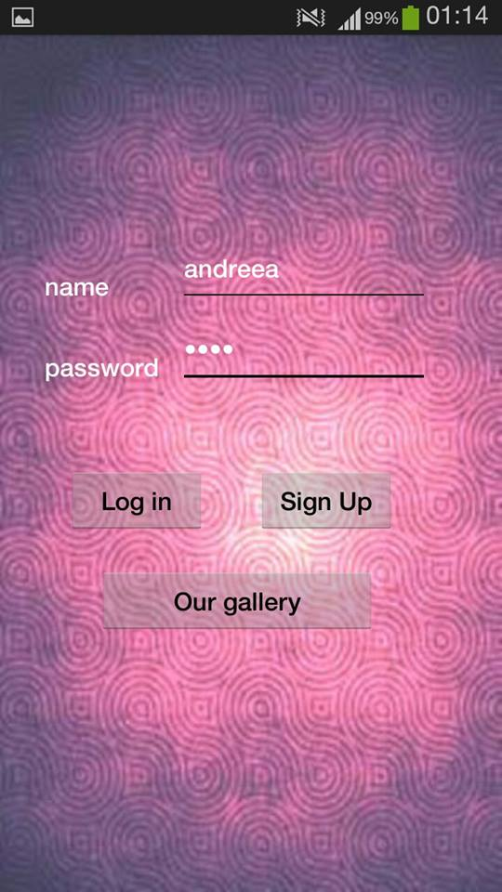

In case the user manages to log in, the home page will be loaded. This page is represented by an image of a product of our shop, on the background, with a personalized welcome message, defined especially for the user in case, as we can see below. (7)

On the home page, after clicking on the button “Log in”, the user can go to his/ her personal profile clicking on “Your Account” button, where he/ she can find the previously defined favorite site in the “Log in” form, (which is, by default, the producer’s site) and also a collage of images which is directing him/ her to official manufacturer site. (8)

We like **happy customers**, so any other improvement or additional function will be added, just to make sure our app is as useful and friendly as possible.

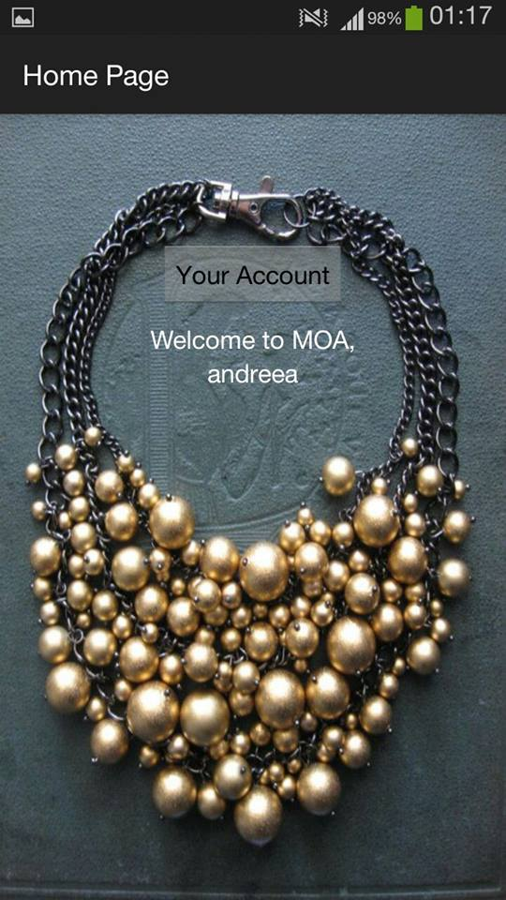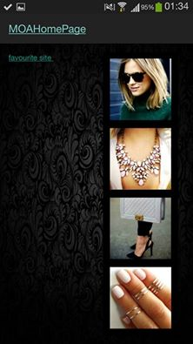

<<Happy women are what we are looking for!>>

MOA

